Part 7: Adding Paint:
47) The final step is to use the Paint Bucket tool to add colors to your car. It may be easier to select the entire car and first paint it the main color. This should probably be done AFTER you print your car. It’s much easier to find errors before the car is painted.
48) Then add other colors for details. Try the “translucent” materials for the windows.
49) Add some colors to the wheels. Try the “metal” materials for the rims.
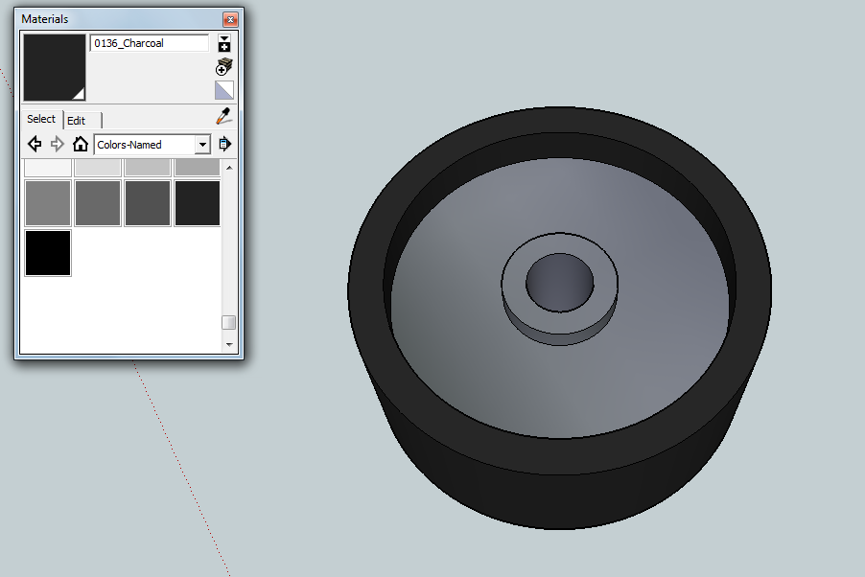

50) Take some screenshots of your car for your design document.
