Part 3: Creating Fenders and Lights
13) Use the offset tool to create another curved edge around the wheel well opening. Make sure to start on the edge of the circle and then pull about 2mm away from the edge.
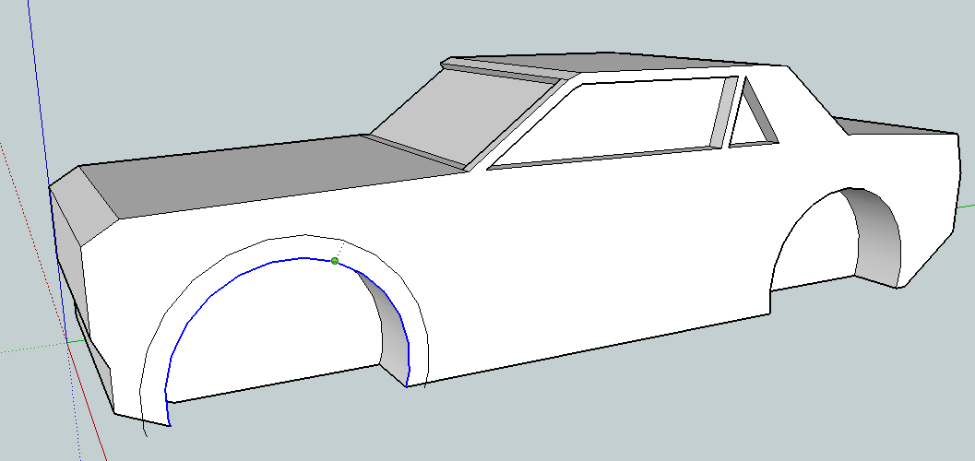
14) Use the move tool to move the inner circle out away from the car (On Red Axis) to form a fender. Make sure to erase the two extra lines sticking out below the base of the car.
You may need to clean them up a little bit at the base. Erase the long diagonal lines and replace with lines from endpoint to endpoint matching them up from the inner circle to the outer circle.
Then repeat for the back wheel well.

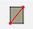
Adding Headlights and Taillights:
15) Use the circle tool or rectangle tool to add a headlight to the front of the car. Remember we are only doing one side of the car right now so you just need one light.
16) Then push/pull the light to give it dimension (1-2mm). Decide if you like it extending out of the car, or pushed into the car. Pushed in will likely print a little better, but either way can work.
If the light is placed on a curved surface (remember it’s much easier to work with straight edges) you may need to do a few extra steps to get the light to pull out.
17) Draw a line to make a rectangle on the back of the car then use the offset tool to make a smaller rectangle inside. Add some more lines if you want more more than one light.
18) Erase the extra lines and the use the push/pull tool to make the lights 3D.
Other Details:
Grill, Hood Scoop, Bumper, Spoiler, License Plate Indention, Exhaust Pipes, …
Make sure you are completely happy with your car before you move on to the next step.

