EV3 Robot C Challenge – Quick Reference Guide
- Setting up the motors and sensors:
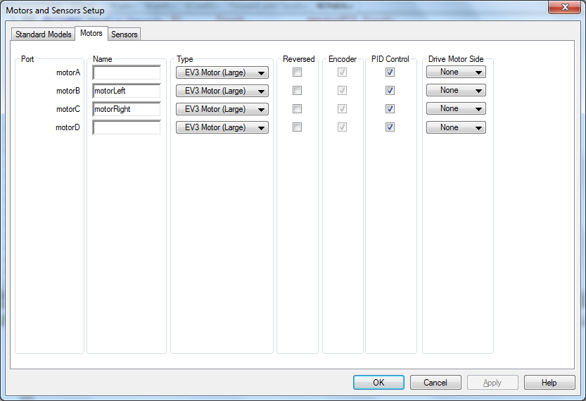
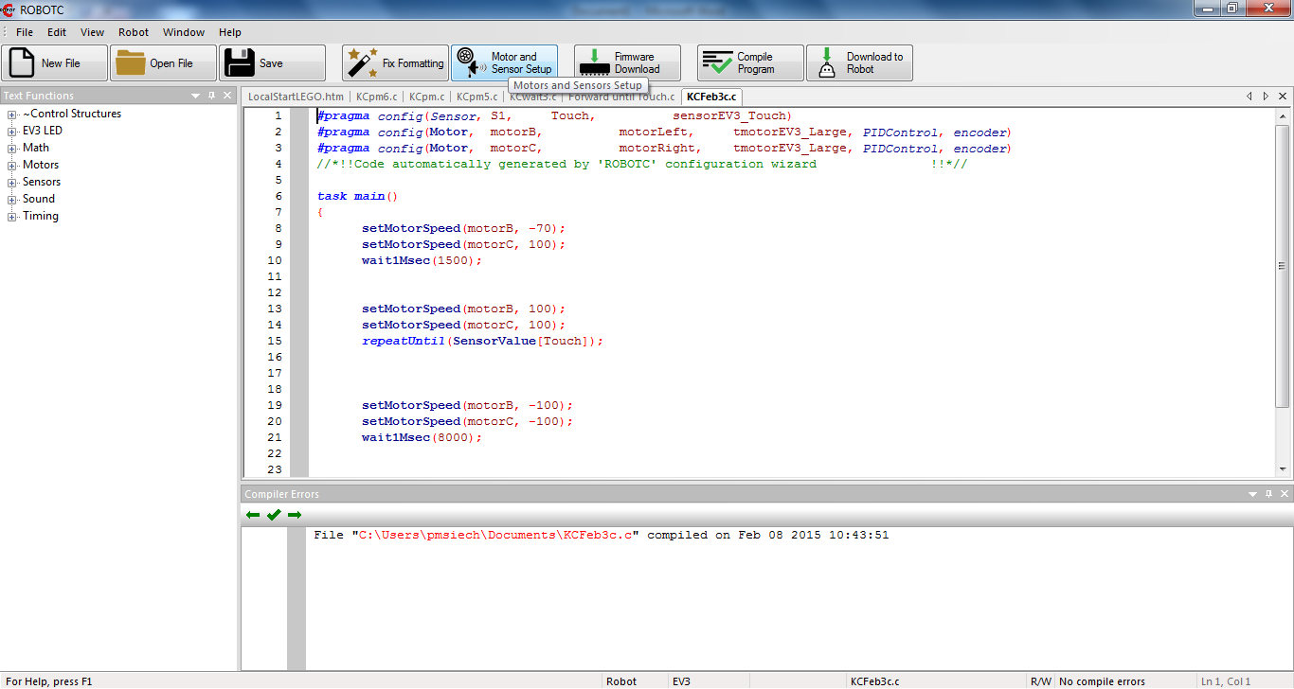
Select the motor and sensor tab and name your motors and sensors

- Driving forward and reverse:
In the “task main” area after the open bracket, type

setMotorSpeed(motorB, 100);

This tells the motor on port B to run at full speed ( 100 ). The semicolon is used to end each line code. The motor can also be referred to as whatever you named it during the setup. You will need to repeat the command for the second drive motor using the same structure. To run in reverse, use the same command structure but insert a - in front of the stated speed. Keep in mind that you can reverse motors in the motor and sensor setup tab…but that direction will remain true for your entire program.

- To set duration of motor run time:
On the line after your motor commands, type
wait1Msec(1500);
This tells the robot to continue the line code(s) above the wait command for 1.5 seconds.

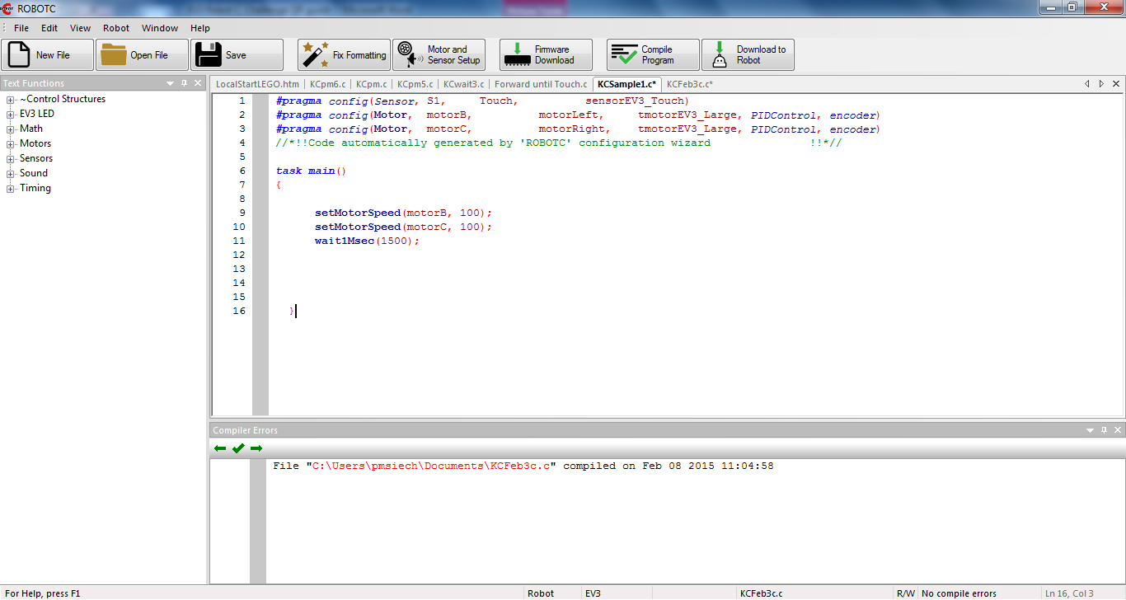
- Steering:
In the “task main” area type

setMotorSpeed(motorA, 50);
setMotorSpeed(motorB, 100);
wait1Msec(1500);

This tells the motors to run at different speeds. Students can experiment with this command to accomplish sweeping turns, point turns, and any other turn type desired. Diameter of wheel and use of gears can have influence over the commands necessary. The differential between speeds and the duration of the command determine the nature of the turn.

- Responding to hitting an obstacle with the touch sensor:
In the “task main” area, after writing the command that will get the robot to the obstacle, type

repeatUntil(SensorValue[Touch]);

This functions as a substitute for a stated wait time. It will execute the line code(s) directly above until the stated condition becomes true ( touch sensor is touched ). It does not affect prior line codes that have stated wait times; they will still execute in order according to the wait times specified. Be sure that the sensor is referred to as exactly the name you specified in the motor and sensor setup. Alternatively, you can refer to the sensor by port ( S1 , if attached to sensor port 1 ).

repeatUntil(SensorValue[S1]);

- Continuing to drive after bumping an obstacle:
Simply write desired line code after the repeatUntil command. Include wait times to set duration.

