

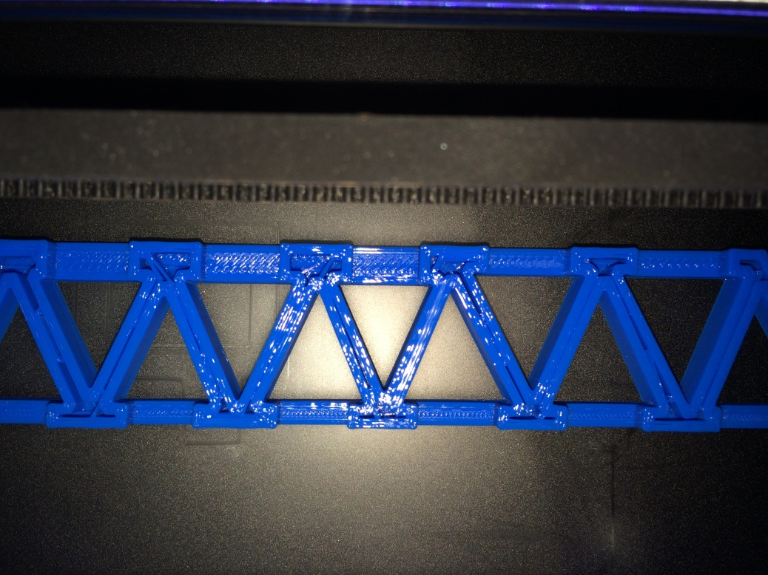 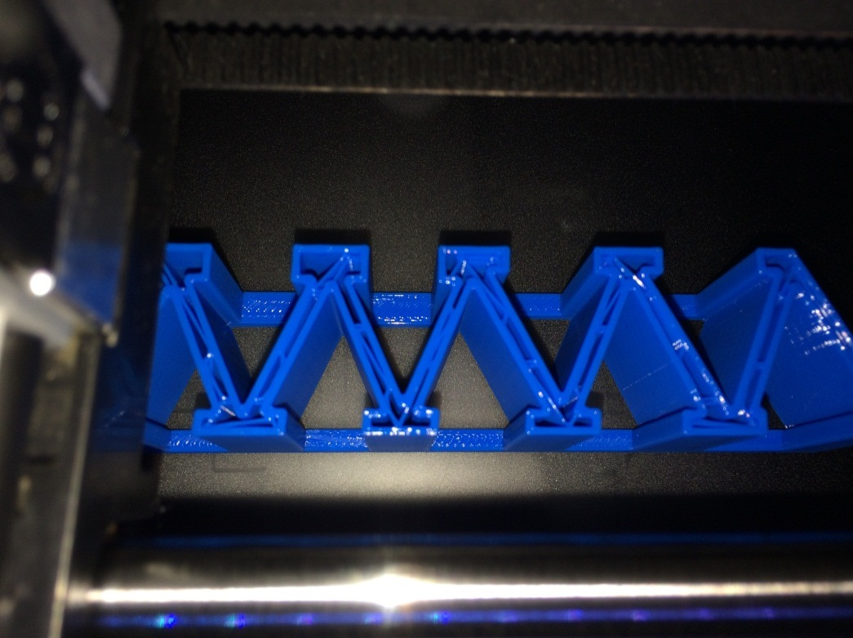 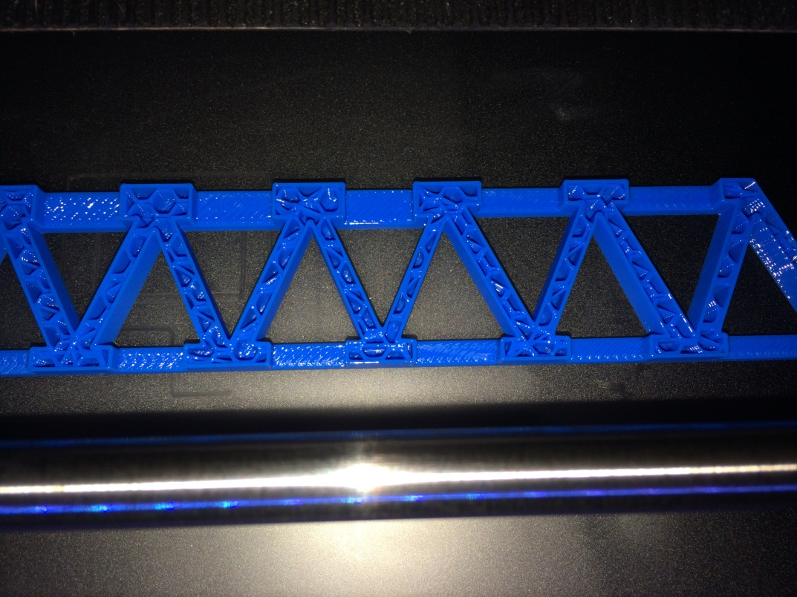



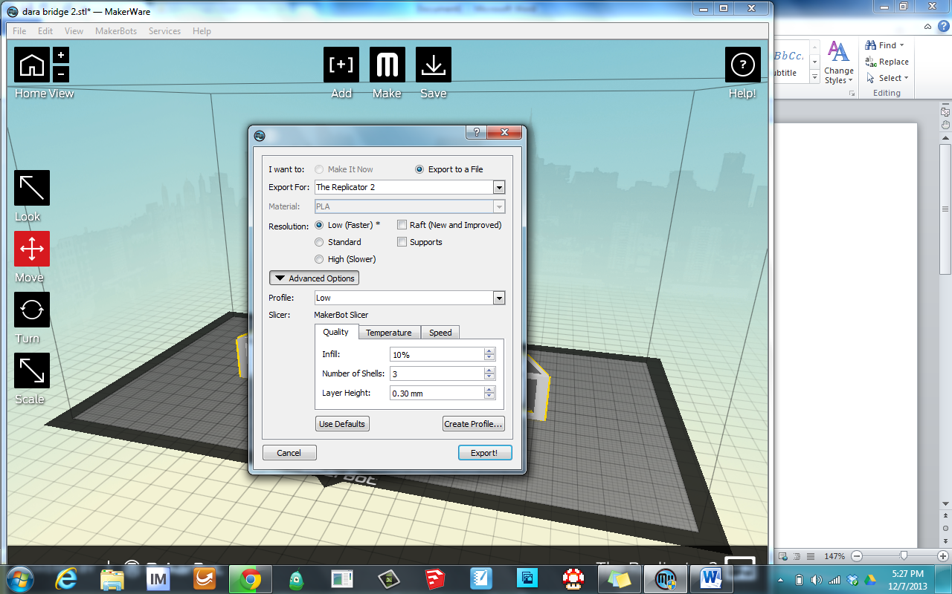 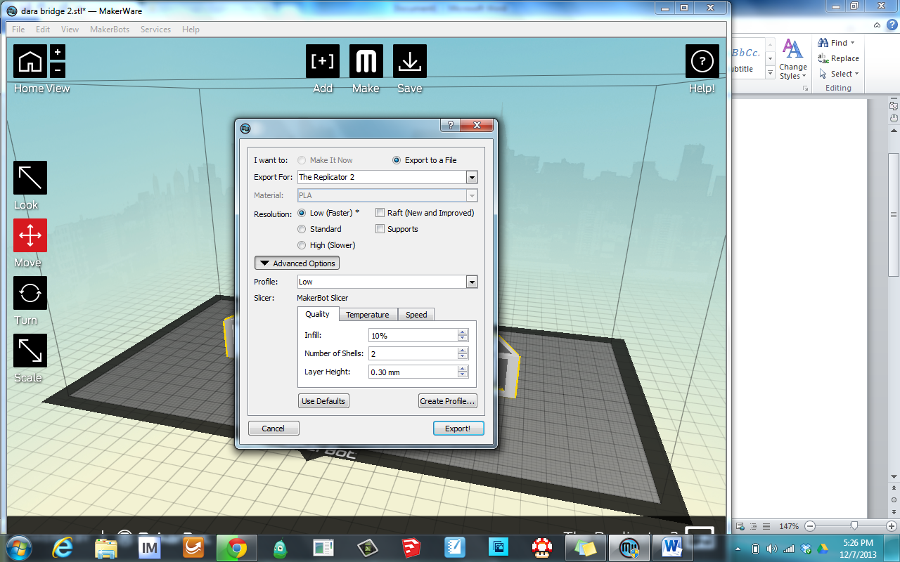 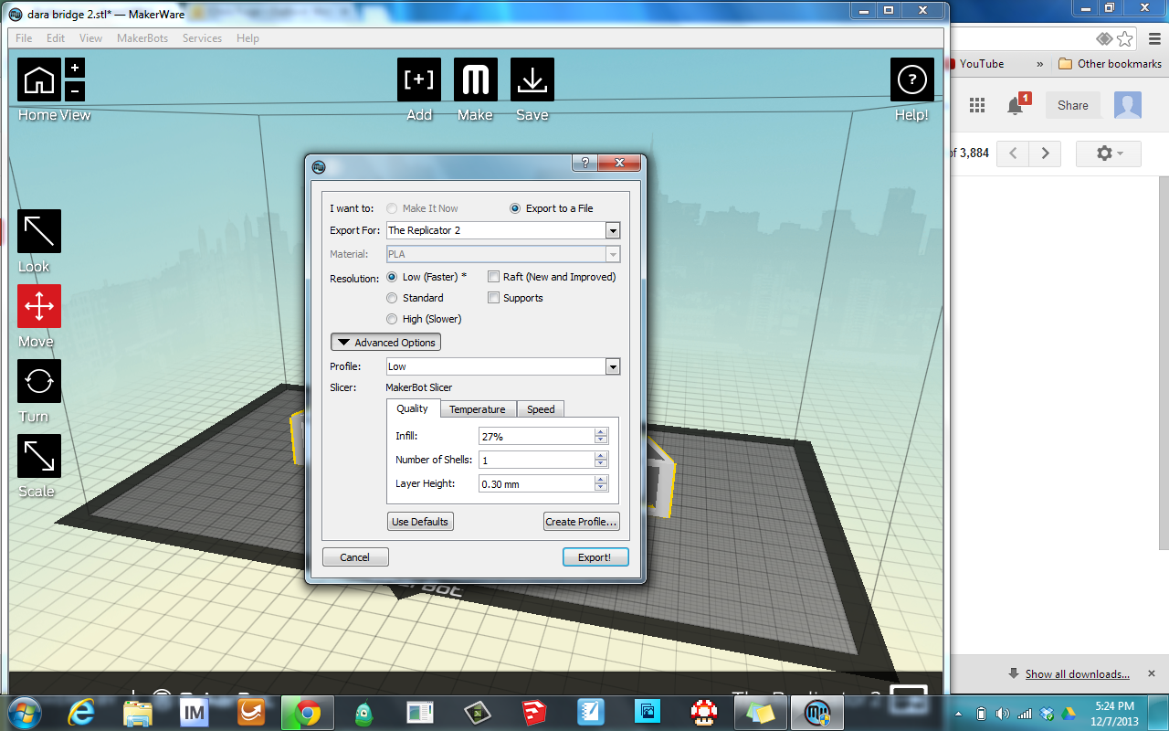



|  |  |  |  |
| --- | --- | --- | --- |
| **Mass** | **36.51 g** | **29.92 g** | **25.09 g** |
| Infill | **10 %** | **10 %** | **27 %** |
| Shells | **3** | **2** | **1** |
| **Load** | **159 lbs** | **139 lbs** | **105 lbs** |
| **Structural Efficiency** | **4.35** | **4.65** | **4.18** |

